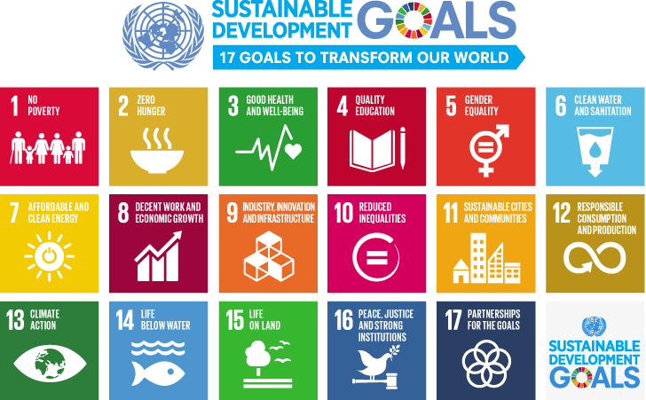

COURSE DESCRIPTION

Sustainable Development Goals
The 2030 Agenda for Sustainable Development:
The particular importance of SDG 8 (Decent Work) for the National Development Agendas

Distance Learning Course
(Duration: 8 weeks)

BACKGROUND

In 2015, the United Nations adopted the Sustainable Development Goals (SDGs) as the main development framework for the international system. This new universal Agenda contains a set of 17 goals and 169 targets which will drive and stimulate action over the next 15 years and ensure the full implementation of the agenda. The new Agenda builds upon the Millennium Development Goals (MDGs) and complete what has not been achieved, realize human rights for all and achieve gender equality and the empowerment of all women and girls. In an integrated and balanced approach, national-level responses will be defined to support the attainment of the SDGs.

Trade unions remain committed to the SDGs having been fully engaged in its shaping and development. The trade union movement has kept a close watch of the developments in the debates and discussions and have been engaged in the process and eventual adoption of the SDGs.

While the adoption of the SDGs and its indicators can be considered a success, there is a great need to play an active role to ensure effective implementation especially at the national level where responses and strategies which are key for the follow-up and review process. Trade unions capacity to actively participate in these processes need to be honed and increased to enable them to continuously defend and promote workers’ interests, especially on Goal 8 on Growth and Decent Work and other decent work targets in the SDGs. On the other hand, Decent Work is not a goal. It is a driver of sustainable development. More people in decent jobs means stronger and more inclusive economic growth, reducing inequalities and increasing resilience. Therefore, it is crucial that Decent Work holds a significant position, being a priority in the National Development Agendas, in accordance with the commitments undertaken by the states until 2030.

This activity is a training course which aims to contribute to develop trade union capacities members to influence the integration of workers’ and trade union perspectives to the SDGs at various levels. Participants are expected to share experiences and broaden their expertise on how to popularize, shape and implement the SDG agenda at the regional and national level. It means that this course will also provide guidelines and criteria for the preparation of case specific plans and strategies, with a special focus on the Decent Work.

ACTIVITY OBJECTIVES
This distance learning course is aimed at building the capacity of trade unions affiliated to FICSA in the area of the Agenda 2030 for Sustainable Development. Upon completion of the workshop, the participants will be able to:
1. Demonstrate a broad understanding of the Sustainable Development Goals: how these Goals came into being;
2. Analyse SDG Goal 8, which is closely aligned with the Decent Work Agenda, and explore other decent work targets within the SDGs; Identify issues and proposals, but also key actors, who should be included and consulted in the design of policy and programmes related to Decent Work or SDG Goal 8;
3. Gain specific competencies on areas where actions are necessary to introduce, promote and defend the staff strategies in the follow up and monitoring the progress of SDGs, especially at the national level;
4. Formulate an action plan which will identify targets and goals for getting involved and engaged at the national SDG processes;
6. Form a core group of union functionaries and officers who will actively pursue integrated and coherent efforts in relation to the implementation, follow/up and monitoring of the SDGs at various levels; and
5. Be promoters of SDG Goal 8 in the national policy and development programmes, in special those development assistance programmes under the auspices of the United Nations agencies, focussing on a national perspective.

ACTIVITY STRUCTURE AND CONTENTS

Estimated study hours for the Tutor-assisted distance-learning period: 50 hours (approx. 6hrs per week). We will use the SoliComm platform that has been created to promote training activities and discussions with trade unions’ lenses.
During this period, you will have access to the on-line platform through which you will:
- learn, both individually and in a collective way;
- receive support from a tutor and the professors with expertise in the subject matters;
- participate in forums, using the documentation provided in the platform; and
- network with fellow participants.
The Course is structured around the 17 Sustainable Development Goals and the Decent Work Agenda, as a development approach and purpose of social justice.

It covers six specific modules addressing the topic of the e-learning course, and a final module focused on the preparation of the follow-up work plan by participants. During the course, compulsory reference material will be indicated to give to the participants the appropriate tools to follow the course and achieve the final work plan. Optional material will be also provided in order to improve the knowledge of the participants on the module’s topic.

At the beginning of each week you will receive from the tutor an Introduction to the Module detailing the contents and references to the readings of each topic.

You will also receive a Study Plan that organizes your studying and the learning content during the distance learning. Please read it carefully.

Given that everyone retains a different background, experience and knowledge in sustainable development, it is important that you actively use the distance learning platform, that you read the materials, complete the assignments, and interact with the tutor, and with others participants, sharing your competencies and your doubts.

For best use of the course by participants, the following approach is suggested:

•Read in advance the material corresponding to each week
•Read the messages issued during the module development by the Tutor and the participants
•Participate with a minimum of two weekly messages during the days corresponding to each module
•Express any questions and need of clarification to the tutor, need examples, depth, etc.

It is very important that you don´t have any doubt about the use of the SoliComm platform, the course structure, its objectives and implementation. Therefore, if you have any question please don’t hesitate contact us so we can begin work together next week.

PARTICIPANTS’ PROFILE

Participants must be:
- member of the staff union/association committee (UN Organizations); OR
- member of the staff union/staff association in every UN Organization
The nominating organisation is strongly urged to place a special emphasis on the nomination of women candidates who may have the subject area as part of their responsibilities or will have in the future.
- Methodology
Active learning methods will be employed throughout the course, which will encourage the participants to take part in group discussions and to be fully involved in all aspects of training. In essence, the training will consist of a combination of individual exercises and interactive sessions. Also, an interactive-final held at each weekly session will help in reviewing and in rendering conclusions operational.

- Evaluation
At the end of the course, an evaluation form concerning pedagogical and organizational aspects of the course will be distributed, thus enabling participants to give their opinion on the course, as well as providing the coordination team with useful insights for tuning and improving future activities.

- Language
The course will be conducted in English and Spanish. Participants are expected to fully involve themselves in individual activities and group discussions. Therefore, they must be able to understand, speak and write in English. However, advanced English writing skills are not a requirement.

- Duration and Dates
This online distance learning course will consist of a duration of eight weeks from 2 October 2017 to 1 December 2017. Participants will be expected to provide 6/8 hours per week to their course studies. However, not all this time will be spent online.

